**C code in Linux Terminal**

Tasks:

Taskno_01:

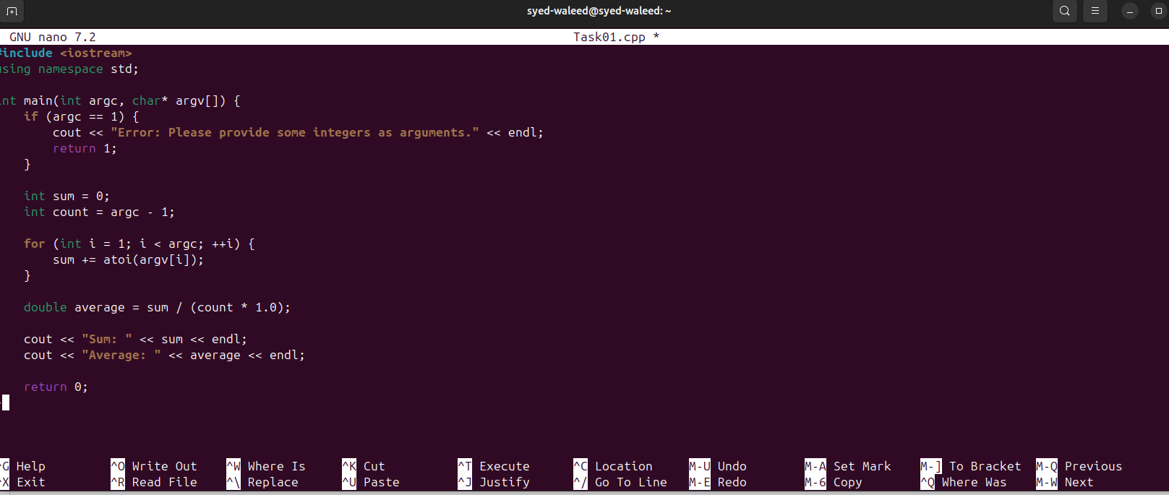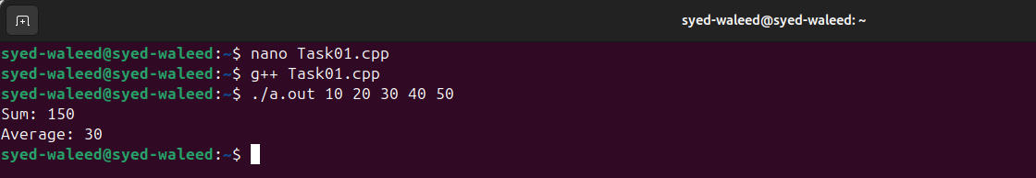

Code of Taskno_01:

#include <iostream>

using namespace std;

int main(int argc, char* argv[]) {

if (argc == 1) {

cout << "Error: Please provide some integers as arguments." << endl;

return 1;

}

int sum = 0;

int count = argc - 1;

for (int i = 1; i < argc; ++i) {

sum += atoi(argv[i]);

}

double average = sum / (count * 1.0);

cout << "Sum: " << sum << endl;

cout << "Average: " << average << endl;

return 0;

}

Taskno_02:

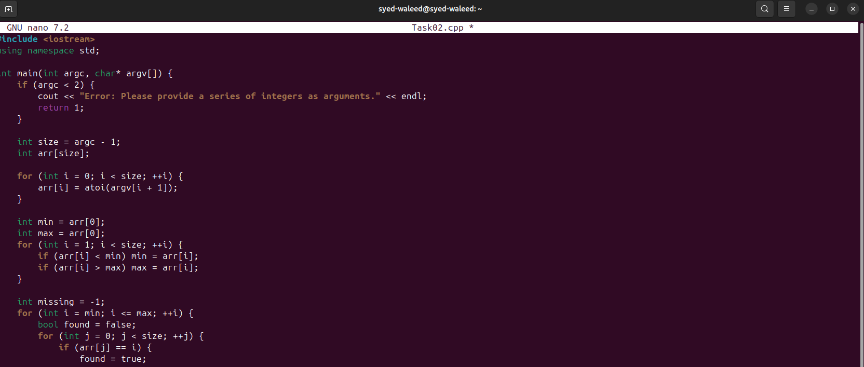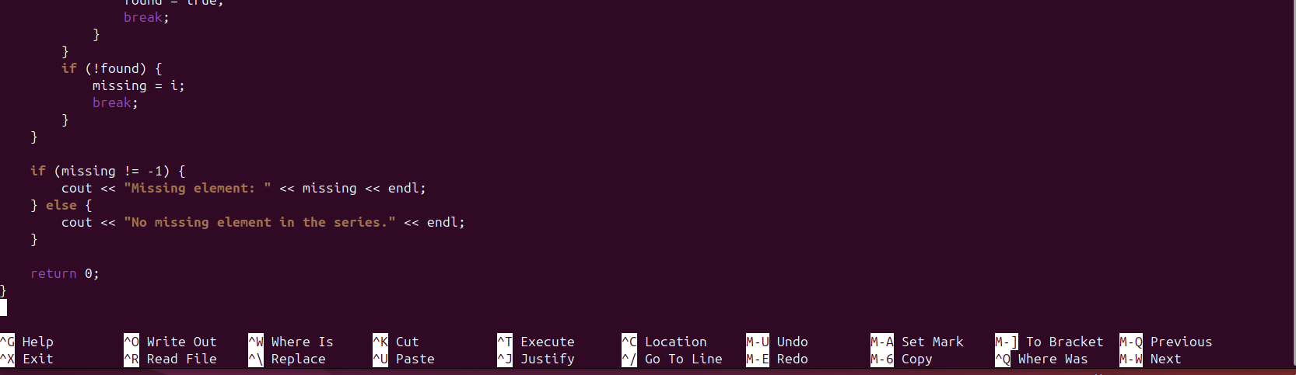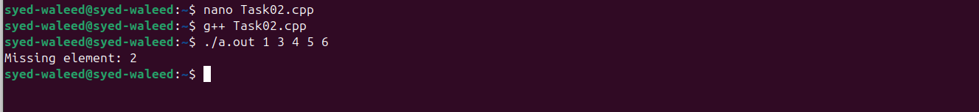

Code of Taskno_02:

#include <iostream>

using namespace std;

int main(int argc, char* argv[]) {

if (argc < 2) {

cout << "Error: Please provide a series of integers as arguments." << endl;

return 1;

}

int size = argc - 1;

int arr[size];

for (int i = 0; i < size; ++i) {

arr[i] = atoi(argv[i + 1]);

}

int min = arr[0];

int max = arr[0];

for (int i = 1; i < size; ++i) {

if (arr[i] < min) min = arr[i];

if (arr[i] > max) max = arr[i];

}

int missing = -1;

for (int i = min; i <= max; ++i) {

bool found = false;

for (int j = 0; j < size; ++j) {

if (arr[j] == i) {

found = true;

break;

}

}

if (!found) {

missing = i;

break;

}

}

if (missing != -1) {

cout << "Missing element: " << missing << endl;

} else {

cout << "No missing element in the series." << endl;

}

return 0;

}

Taskno_03:

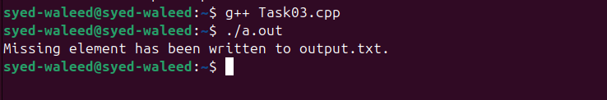

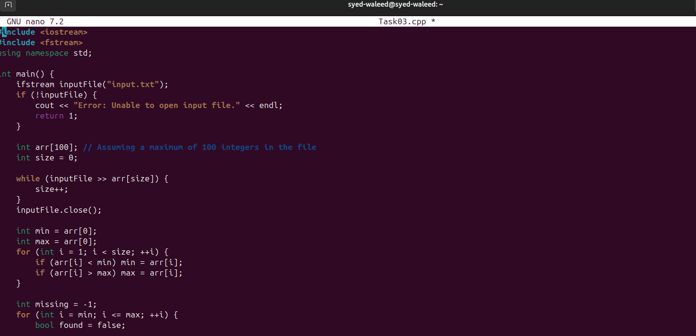

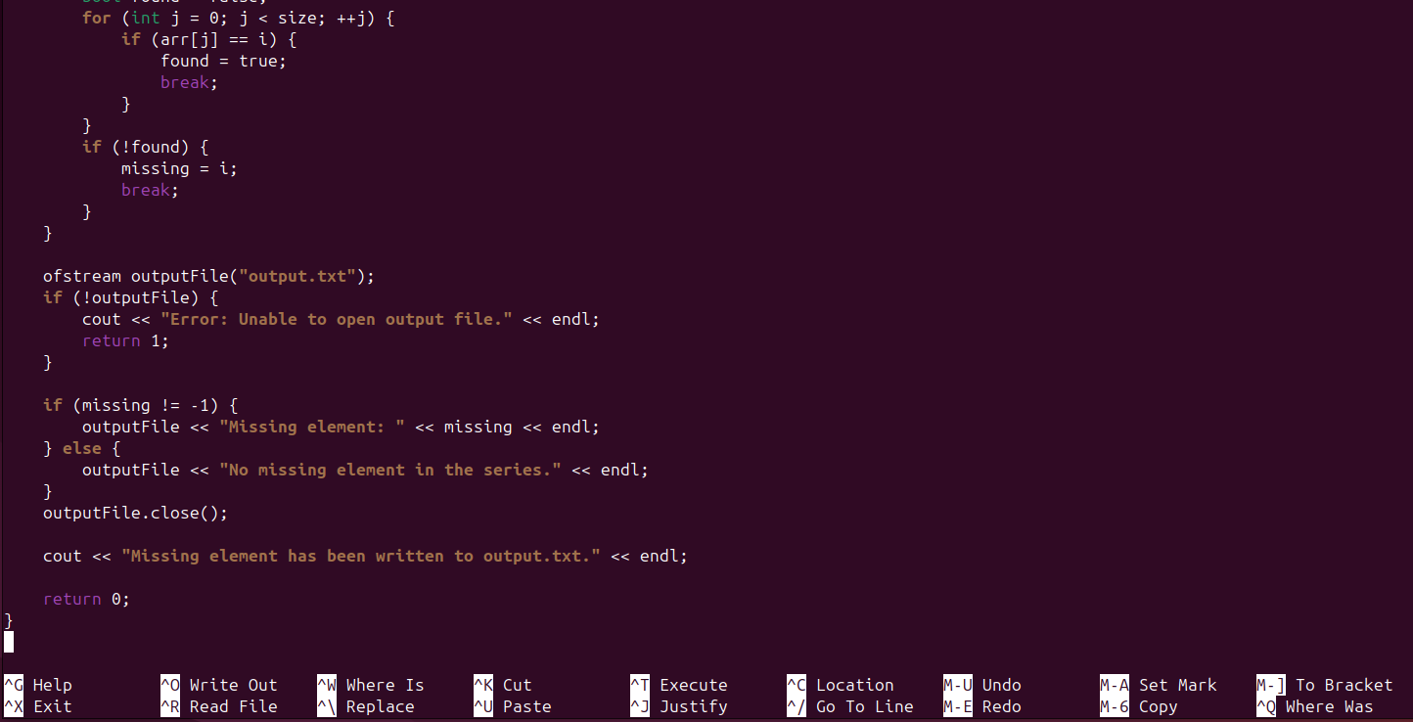

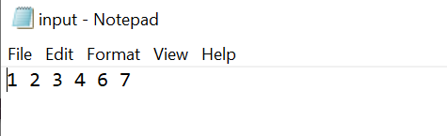

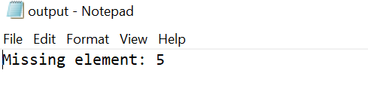

Code of Taskno_03:

#include <iostream>

#include <fstream>

using namespace std;

int main() {

ifstream inputFile("input.txt");

if (!inputFile) {

cout << "Error: Unable to open input file." << endl;

return 1;

}

int arr[100]; // Assuming a maximum of 100 integers in the file

int size = 0;

while (inputFile >> arr[size]) {

size++;

}

inputFile.close();

int min = arr[0];

int max = arr[0];

for (int i = 1; i < size; ++i) {

if (arr[i] < min) min = arr[i];

if (arr[i] > max) max = arr[i];

}

int missing = -1;

for (int i = min; i <= max; ++i) {

bool found = false;

for (int j = 0; j < size; ++j) {

if (arr[j] == i) {

found = true;

break;

}

}

if (!found) {

missing = i;

break;

}

}

ofstream outputFile("output.txt");

if (!outputFile) {

cout << "Error: Unable to open output file." << endl;

return 1;

}

if (missing != -1) {

outputFile << "Missing element: " << missing << endl;

} else {

outputFile << "No missing element in the series." << endl;

}

outputFile.close();

cout << "Missing element has been written to output.txt." << endl;

return 0;

}

Taskno_04:

Creating files :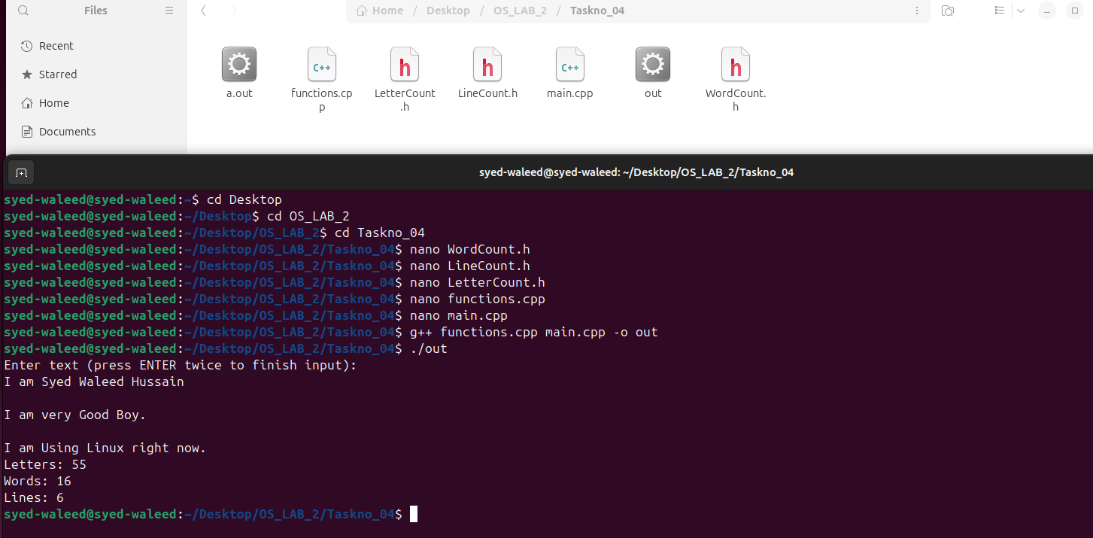

Creating makefile:

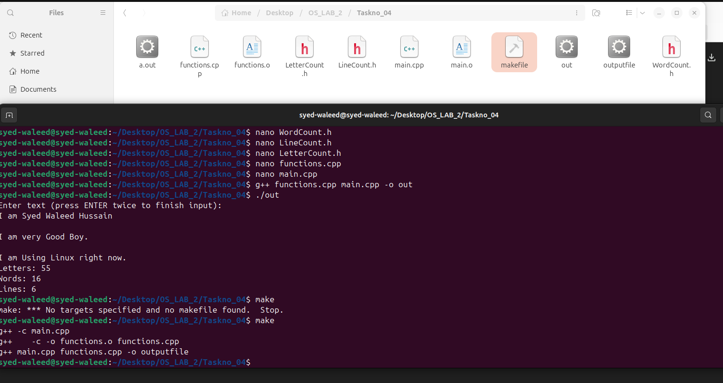

Removing Makefile:

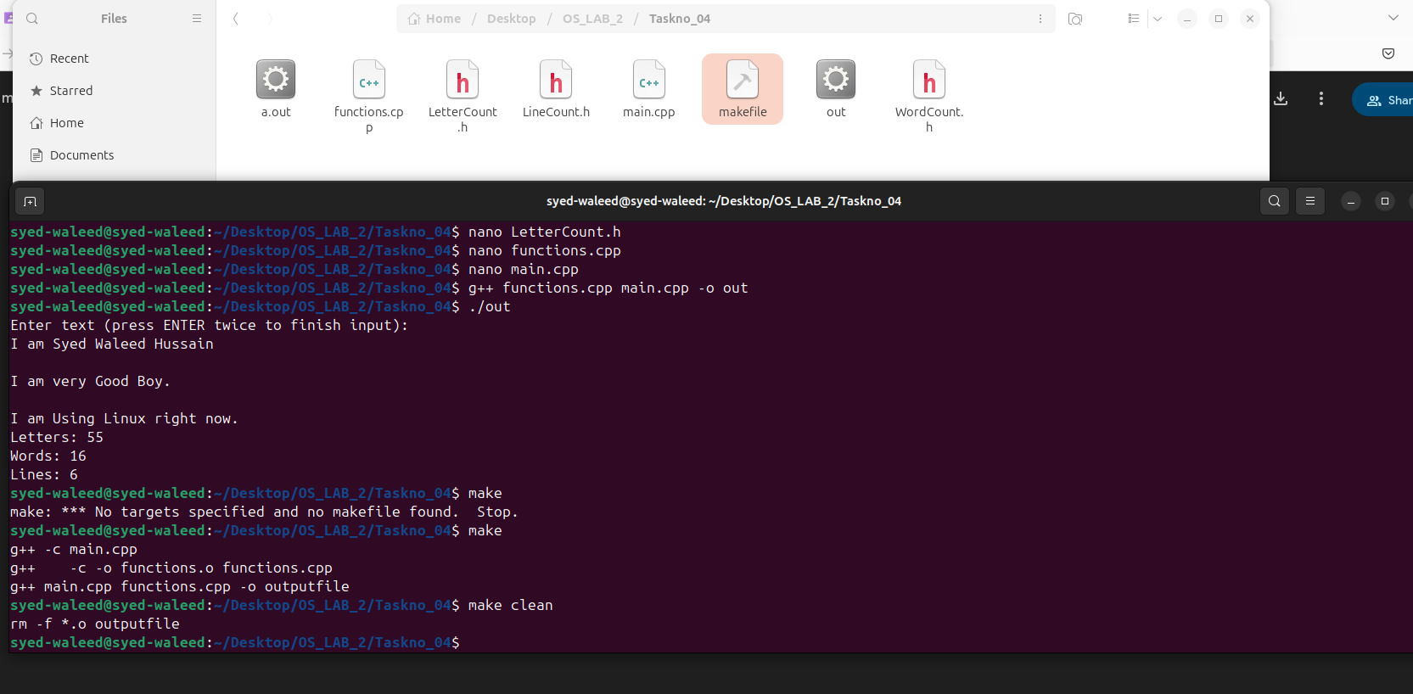

Code of LetterCount.h:

ifndef LETTERCOUNT_H

#define LETTERCOUNT_H

#include <string>

using namespace std;

class LetterCount {

public:

int countLetters(string text);

};

#endif

Code of WordCount.h:

#ifndef WORDCOUNT_H

#define WORDCOUNT_H

#include <string>

using namespace std;

class WordCount {

public:

int countWords(string text);

};

#endif

Code of LineCount.h:

#ifndef LINECOUNT_H

#define LINECOUNT_H

#include <string>

using namespace std;

class LineCount {

public:

int countLines(string text);

};

#endif

Code of functions.cpp:

#include "LetterCount.h"

#include "WordCount.h"

#include "LineCount.h"

int LetterCount::countLetters(string text) {

int count = 0;

int i = 0;

while (text[i] != '\0') {

if ((text[i] >= 'a' && text[i] <= 'z') || (text[i] >= 'A' && text[i] <= 'Z')) {

count++;

}

i++;

}

return count;

}

int WordCount::countWords(string text) {

int count = 0;

int i = 0;

bool inWord = false;

while (text[i] != '\0') {

if (text[i] == ' ' || text[i] == '\n') {

inWord = false;

} else if (!inWord) {

inWord = true;

count++;

}

i++;

}

return count;

}

int LineCount::countLines(string text) {

int count = 1;

int i = 0;

while (text[i] != '\0') {

if (text[i] == '\n') {

count++;

}

i++;

}

return count;

}

Code of main.cpp:

#include <iostream>

#include "LetterCount.h"

#include "WordCount.h"

#include "LineCount.h"

using namespace std;

int main() {

string text;

cout << "Enter text (press ENTER twice to finish input):" << endl;

getline(cin, text, '\0'); // Reads multiple lines

LetterCount letterCounter;

WordCount wordCounter;

LineCount lineCounter;

int letters = letterCounter.countLetters(text);

int words = wordCounter.countWords(text);

int lines = lineCounter.countLines(text);

cout << "Letters: " << letters << endl;

cout << "Words: " << words << endl;

cout << "Lines: " << lines << endl;

return 0;

}

Code of Makefile:

outputfile: main.o functions.o

g++ main.cpp functions.cpp -o outputfile

main.o: main.cpp

g++ -c main.cpp

function.o: functions.cpp

g++ -c functions.cpp

clean:

rm -f *.o outputfile

run: outputfile

./outputfile

---------------------------------------------------------------------------------------------------------------------------------------